Blazor

Module 2: Overview

Student Lab Manual

Instructor Edition (Book Title Hidden Style)

**Conditions and Terms of Use**

**Microsoft Confidential**

This training package is proprietary and confidential, and is intended only for uses described in the training materials. Content and software is provided to you under a Non-Disclosure Agreement and cannot be distributed. Copying or disclosing all or any portion of the content and/or software included in such packages is strictly prohibited.

The contents of this package are for informational and training purposes only and are provided "as is" without warranty of any kind, whether express or implied, including but not limited to the implied warranties of merchantability, fitness for a particular purpose, and non-infringement.

Training package content, including URLs and other Internet Web site references, is subject to change without notice. Because Microsoft must respond to changing market conditions, the content should not be interpreted to be a commitment on the part of Microsoft, and Microsoft cannot guarantee the accuracy of any information presented after the date of publication. Unless otherwise noted, the companies, organizations, products, domain names, e-mail addresses, logos, people, places, and events depicted herein are fictitious, and no association with any real company, organization, product, domain name, e-mail address, logo, person, place, or event is intended or should be inferred.

© 2020 Microsoft Corporation. All rights reserved.

**Copyright and Trademarks**

© 2020 Microsoft Corporation. All rights reserved.

Microsoft may have patents, patent applications, trademarks, copyrights, or other intellectual property rights covering subject matter in this document. Except as expressly provided in written license agreement from Microsoft, the furnishing of this document does not give you any license to these patents, trademarks, copyrights, or other intellectual property.

Complying with all applicable copyright laws is the responsibility of the user. Without limiting the rights under copyright, no part of this document may be reproduced, stored in or introduced into a retrieval system, or transmitted in any form or by any means (electronic, mechanical, photocopying, recording, or otherwise), or for any purpose, without the express written permission of Microsoft Corporation.

For more information, see Use of Microsoft Copyrighted Content at  
<http://www.microsoft.com/en-us/legal/intellectualproperty/Permissions/default.aspx>

Internet Explorer, Microsoft, SQL Server, Visual Studio, and Windows are either registered trademarks or trademarks of Microsoft Corporation in the United States and/or other countries. Other Microsoft products mentioned herein may be either registered trademarks or trademarks of Microsoft Corporation in the United States and/or other countries. All other trademarks are property of their respective owners.

Contents

Lab 2: Implementing Blazor 1

Exercise 1: Get started with ASP.NET Core Blazor 3

# Lab 2: Implementing Blazor

#### Introduction

The aim of this exercise is to explore implementing an application using the new application model introduced under ASP.Net Core 3 called Blazor.

Important

**Blazor WebAssembly in preview**

Blazor Server is supported in ASP.NET Core 3.0. Blazor WebAssembly is in preview for ASP.NET Core 3.1.

#### Objectives

After completing this lab, you will be able to:

* Create a new ASP.NET Core Blazor application in Visual Studio 2019.

#### Prerequisites

None

#### Scenario

In this scenario, we will explore implementing an online Pizza Delivery application.

#### System Requirements

* Follow the instructions found [on this page](https://docs.microsoft.com/en-us/aspnet/core/blazor/get-started?view=aspnetcore-3.1&tabs=visual-studio) to get started

#### Estimated Time to Complete This Lab

30 minutes

Exercise 1: Get started with ASP.NET Core Blazor

#### Objectives

In this exercise, you will:

* Create a new ASP.NET Core 3 Blazor
* Understand the structure of a Blazor project

#### Scenario

Create a new ASP.Net Core 3 Blazor application and run it.

Task 1: Create the New Project

1. Install the latest [Visual Studio](https://visualstudio.com/vs/) with the **ASP.NET and web development** workload.
2. Create a new project.

1. Select **Blazor App**. Select **Next**.

1. Provide a project name in the **Project name** field or accept the default project name. Confirm the **Location** entry is correct or provide a location for the project. Select **Create**. Call the Application “MyFirstBlazorApp”.

1. For a Blazor WebAssembly experience, choose the **Blazor WebAssembly App** template. For a Blazor Server experience, choose the **Blazor Server App** template. For this exercise we will go with the Blazor Server Option. Select **Create**. For information on the two Blazor hosting models, Blazor Server and Blazor WebAssembly, see [ASP.NET Core Blazor hosting models](https://docs.microsoft.com/en-us/aspnet/core/blazor/hosting-models?view=aspnetcore-3.0).

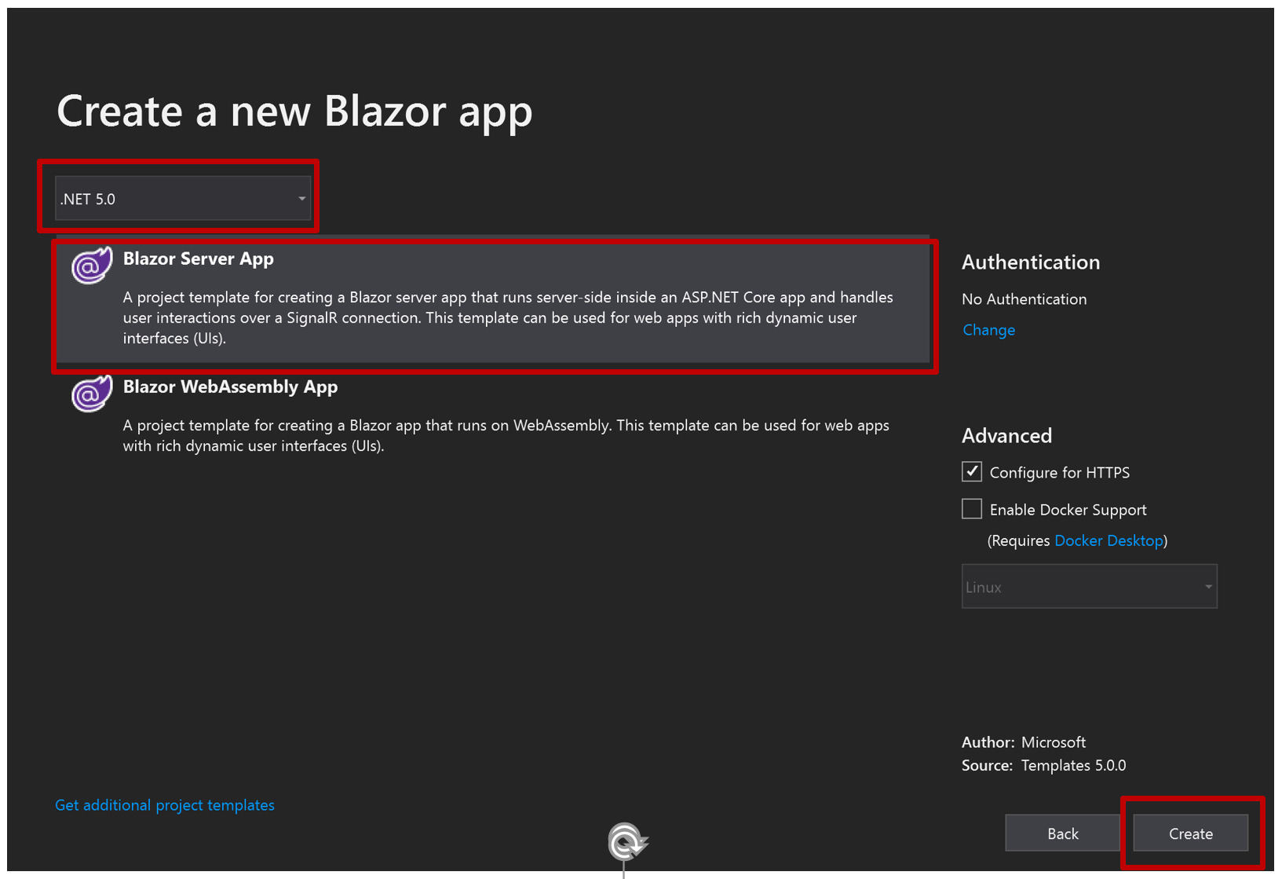

1. Press **F5** to run the app.

